**Department of Computer Engineering**

BLG 351E  
Microcomputer Laboratory Experiment Report

Experiment No : 6

Experiment Date : 24.11.2017

Group Number : Friday - 13

Group Members :

|  |  |  |
| --- | --- | --- |
| **ID** | **Name** | **Surname** |
| 150160537 | OKAN | YILDIRIM |
| 150160546 | HASAN EMRE | ARI |
| 150120144 | SAİM FATİH | ERMİŞ |
|  |  |  |

*SAİM FATİH ERMİŞ is member of another group normally, yet we did this experiment 6’s make-up together.

Laboratory Assistant : Yusuf Hüseyin Şahin

# Introduction

In this experiment we design a chronometer with centisecond precision by using MSP430 Education Board, MSP430G2553 microcontroller and its assembly language. We enhanced the practical experience. Before the experiment, we studied on MSP430 User Guide – Timer A chapter document and Background information on experiment sheet. We get familiar with using 7-segment display and interrupts. We did preliminary work.

# Experiment

## Part 1

In this program of the experiment, we write code to lit determined digits of 7-segment display panel in an infinite loop. We lit 0123 digits on 7-segment display.

Our program and detailed description is given below:

Setup bis.b #11111111b, &P1DIR

bis.b #00001111b, &P2DIR

Mainloop mov.w #00001000b, &P2OUT

mov.w #01001111b,R5

mov.b R5,&P1OUT

clr &P1OUT

mov.w #00000100b, &P2OUT

mov.w #01011011b,R5

mov.b R5,&P1OUT

clr &P1OUT

mov.w #00000010b, &P2OUT

mov.w #00000110b,R5

mov.b R5,&P1OUT

clr &P1OUT

mov.w #00000001b, &P2OUT

mov.w #00111111b,R5

mov.b R5,&P1OUT clr &P1OUT

jmp Mainloop

Firstly, we initialized Port 1 and Port 2 to activate and use 7-segment display. Then, we assigned the values 0,1,2 and 3 to the determined 7-segment display panel simultaneously and turn on the digits on the LEDs. After the each lit we clear the P1OUT. Therefore, 0, 1, 2 and 3 are lit on the 7-segment panel simultaneously in an infinite loop. It happens too fast that all panels seem to be lit at the same time.

## Part 2

In this part, we implemented a time interrupt subroutine, interrupt subroutine and convert subroutine by enhancing the main part of the previous part above in order to build the chronometer. We added required parts for using interrupt subroutine. We fallowed the steps given on the experiment sheet. Especially, MSP430 User Guide – Timer A chapter is very important to construct timer interrupt program.

Our code is given below:

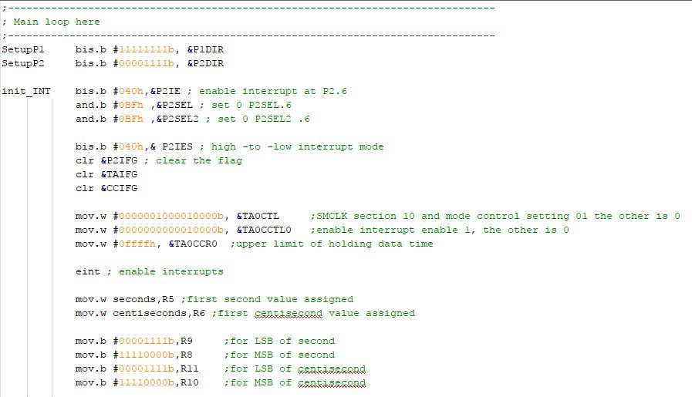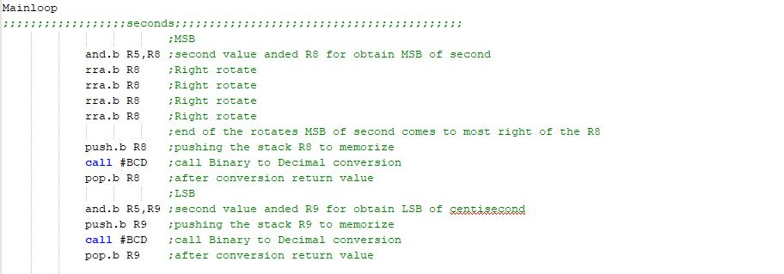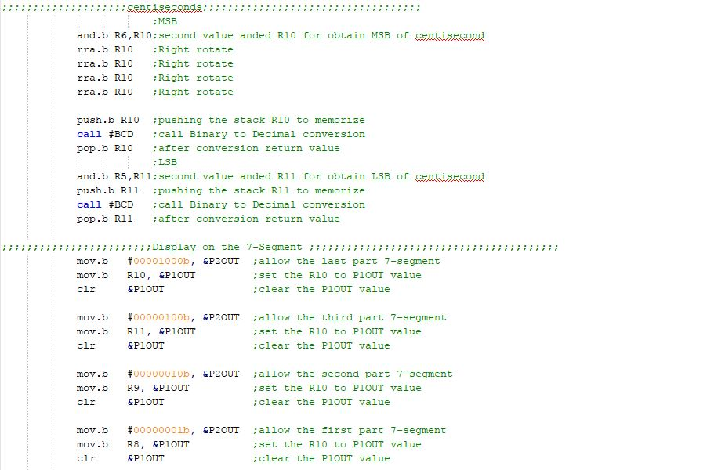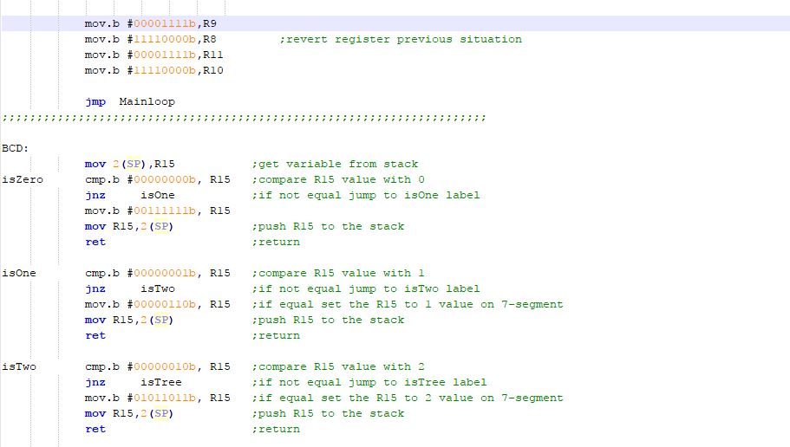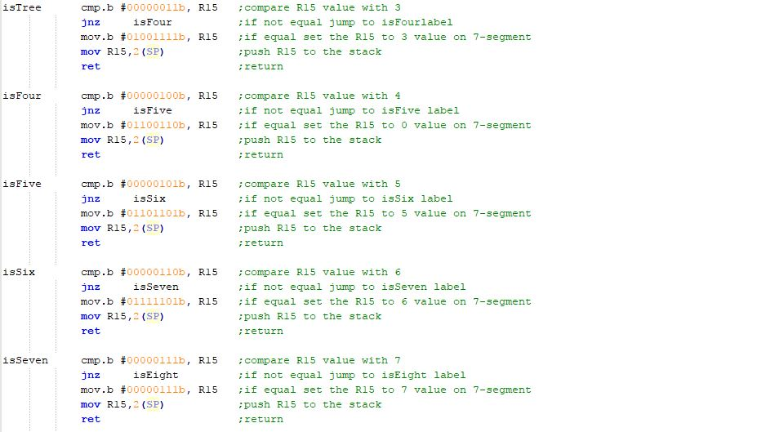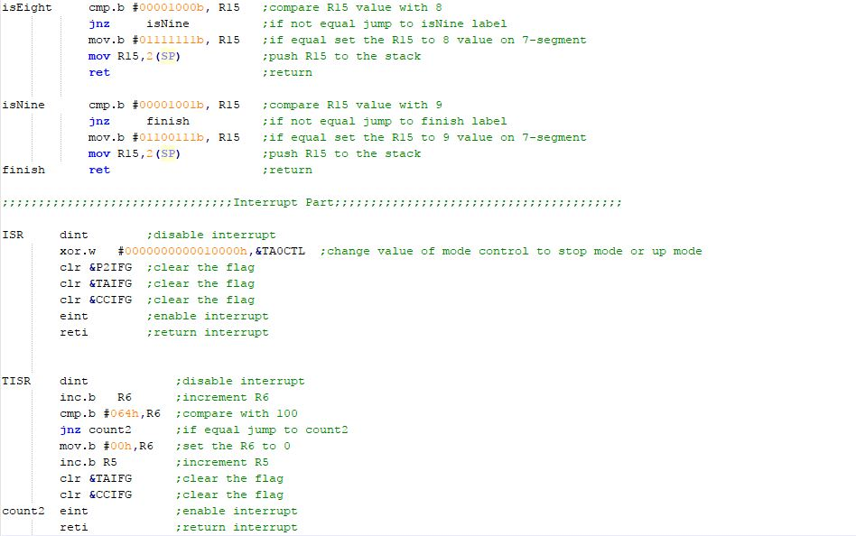

Firstly we store second and centisecond values on RAM in the data section. Then, we initialize the interrupt on PORT2, 6th button for stop and start interrupt and we clean the required flags. We assign the values to TA0CTL, TA0CCTL0 and TA0CCR0 registers bit by bit according to the MSP430 User Guide – Timer A chapter pages from 370 to 373. Second value is assigned to the R5 and centisecond value is assigned to R6 register. At the ISR part, if sixth button is pressed interrupt become enable and stop or start chronometer according to the toggle of the value on the TA0CTL register with 16 sized bit value which is the determined by us according to the document. In TISR part, we check if the centimeter part (rightest two part of 7-segment panel) access to the 100 (64h) or not. If it access to 100, set 0 to this part and increment the second part (leftest two part of 7-segment panel). Otherwise it continues the increment the centisecond. In Main part, as explained in the comments, the first and second digits of centisecond and second are separated using BCD. The BCD operation acts as a switch case. It first determines what value it is by comparing it with the values from 0 to 9. Subsequently, the R15 register is written in the 7-segment value it determines.

# Conclusion

We learn much about TIMER A and TISR interrupt. Although everything is apparently smooth, the 2nd and 3rd bits in the 7 segments show the same value and increase at the same time. We have not found a solution to this problem until the end of the experiment. The rest of the experiment is working correctly.